Name: Srđan Kovačević
E-mail: srdjankovacevic@uns.ac.rs
Institution: University of Novi Sad, Faculty of Technical Sciences
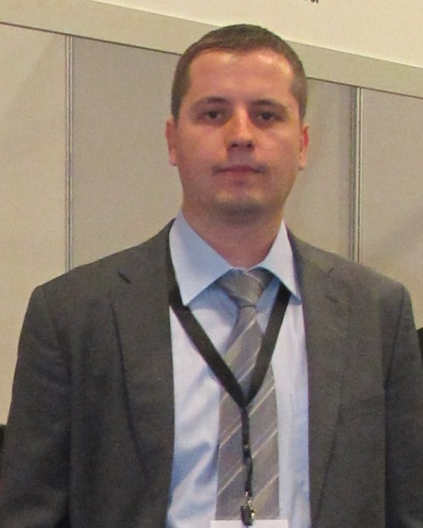 | PhD Srđan Kovačević (1983) is Research Associate on Department of Environmental Engineering and Occupational Health and Safety, Faculty of Technical Science at University of Novi Sad. He is engaged in development and realization of the following subjects: Basic Principles of Water Management, Use, Protection and Groundwater Management and River Basin Management.  PhD Srđan Kovačević is author and co-author of more than 70 scientific papers and he has been participated in more than 10 national and international projects.  PhD Srđan Kovačević graduated (2008) Environmental Engineering (MSc - Master Academic Studies) at Faculty of Technical Science at University of Novi Sad (UNS). He obtained his Ph.D. (2017) degree in Environmental Engineering, Faculty of Technical Science at University of Novi Sad. Thesis, Analysis of Groundwater Self-Purification Potential for Removal of Pharmaceuticals Applying River Bank Filtration Method. He is an active member and board member of SSWP (Serbian Society for Water Protection) and active member of IWA-YWP (International Water Association -Young Water Professionals) and SeSWA (Serbian Solid Waste Association).  The present scientific and research work is focused on analysis of groundwater use and protection, using conceptual model of river bank filtration in alluvial aquifers. More general scientific and research work is focused on water management systems development in the field of wastewater treatment (especially material and substance flow analysis), drinking water treatment and protection of groundwater resources and systematic impact evaluation on environment. .
References (max. 5 relevant references)

Živančev, N.V., Kovačević, S.R., Radović, T.T., Radišić, M.M., Dimkić, M.A. 2019. Mobility and sorption assessment of selected pesticides in alluvial aquifer, Environmental Science and Pollution Research, Volume 26, Issue 28, pp. 28725-28736, DOI: 10.1007/s11356-019-06055-4.
Mitrinović, D., Kovačević, S., Vojt, P., Pušić, M., Dimkić, M. 2019. Tracer test analysis using flow and transport simulation code and new analytical transport model 27 April 2019, Water Environment Research, Volume 91, Issue 9, pp. 940-953, DOI: 10.1002/wer.1135
Kovačević, S., Radišić, M., Mitrinović, D., Vojt, P., Živančev, N. 2017. Tracer test and behavior of selected pharmaceuticals, Water Science and Technology: Water Supply, Volume 17, Issue 4, pp.1043-1052, DOI: 10.2166/ws.2016.202
Kovačević, S., Radišić, M., Laušević, M., Dimkić, M. 2017. Occurrence and behavior of selected pharmaceuticals during riverbank filtration in The Republic of Serbia, Environmental Science and Pollution Research, Volume 24, Issue 2, pp. 2075-2088, DOI: 10.1007/s11356-016-7959-4.
Radović, T.T., Grujić, S.D., Kovačević, S.R., Laušević, M.D., Dimkić, M.A. 2016. Sorption of selected pharmaceuticals and pesticides on different river sediments, Environmental Science and Pollution Research, Volume 23, Issue 24, pp. 25232-25244, DOI: 10.1007/s11356-016-7752-4.

This project has been funded with support from the European Commission. This publication reflects the views only of the author, and the Commission cannot be held responsible for any use which may be made of the information contained therein.

